# Bus Patronage Dashboard

|  |  |
| --- | --- |
| Intern | Yuchen Zhang |
| Supervisor | Nathan Urban |
| Host Organisation | Transport Canberra and City Services (TCCS) |
| Sponsor | Olivia Jiang - Transport Canberra and Business Service |
| Project Period | 27 Jul 2020 – 01 Nov 2020 |
|  |  |

## INTRODUCTION

Transport Canberra and City Services (TCCS), who delivers a wide range of public services and manages the public transport network, has released an **Open Data Strategy 2019-2021** based on the Proactive Release of Data (Open Data) Policy 2015. This strategy encourages organisations and governments to make data publicly available, and aims to advance the use of open data to improve service delivery and encourage innovation.

This project will work for the Transport Canberra and Business Service team, using Bus and Light Rail Patronage data from the Open Data Portal to perform data visualisation and analysation. The first approach will be building two dashboards to present the performance of public transport network in a higher level and a more detailed level respectively. The second approach will be analysing the effect of seasonality on bus boarding and detecting anomalies data. Aiming to help the clients making operational decisions and monitoring the service delivery performance.

## KEY STAKEHOLDERS – TACI Matrix

1. **Innovation, Data and Analytics Team (IDA Team)**

The IDA team acts as the owner and manager of this project. It provides business intelligence services, helps business units to get insights and make decisions. It is also responsible for the Open Data Strategy, managing data collection and publication.

1. **Transport Canberra and Business Service Team**

The Business Service team act as the client side of this project. It maintains public transport operations including buses and light rail, ensuring the service quality and reliability. It is also responsible for organising the data publish to the Open Data Portal.

1. **Research School of Computer Science, Australian National University (ANU)**

ANU is involved in providing mentoring support to the interns through workshops, small group discussions and one-to-one mentoring sessions. Support will be focus on developing professional skills and enhancing personal skills.

|  |  |  |  |  |
| --- | --- | --- | --- | --- |
| **Tasks and Deliverables** | **Stakeholders** | | | |
| **Analyst (Yuchen)** | **IDA** | **Business Service** | **ANU** |
| Working Environment Setup | R | C |  |  |
| Statement of work | R | A | C | I |
| Dashboard 1 | R | C | A | I |
| Dashboard 2 | R | C | A | I |
| Data Analyzation | R | C | A | I |
| Testing | R | C | R+A | I |
| Report/Documentation | R | A | A | I |
| Showcase Poster | R+A | C | C | I |
| Working Portfolio Package | R+A | C | C | I |

|  |  |
| --- | --- |
| R = Responsible | People or stakeholders who do the work. They must complete the task or objective or make the decision. Several people can be jointly Responsible. |
| A = Accountable | Person or stakeholder who is the "owner" of the work. He or she must sign off or approve when the task, objective or decision is complete. This person must make sure that responsibilities are assigned in the matrix for all related activities. Success requires that there is only one person Accountable, which means that "the buck stops there." |
| C = Consulted | People or stakeholders who need to give input before the work can be done and signed-off on. These people are "in the loop" and active participants. |
| I = Informed | People or stakeholders who need to be kept "in the picture." They need updates on progress or decisions, but they do not need to be formally consulted, nor do they contribute directly to the task or decision. |

## PROBLEM STATEMENT

1. Since the Business Service team needs to report the performance of transport network to the Executive Group Manager, it wishes to consolidate various indicators into a new reporting framework. In order to achieve functional automation, and avoid repetitive computation of same-type indicators. In this case, two dashboards will be built through this project. The transport network performance could be visually presented by these dashboards. Additionally, different indicators could be adjusted by slicing on date range and transport mode (Bus or LightRail, MyWay Card or Ticket) etc.
2. The seasonality analysis on the bus patronage is not yet conducted. While the effect of seasonality is an important property of the Transport network performance. Therefore, the seasonality analysis and furthermore the anomalies detection will need to be conducted on the bus boarding data set.

## OBJECTIVE

1. Build dashboards:

* To present travel patterns of different passenger groups and mode shifts;
* To provide ongoing monitoring on Public Transport service delivery (Bus & Light Rail);

1. Perform data analyzation to support future business cases:

* Analyze effect of seasonality;
* Detect anomalies in patronage.

## PROJECT BENEFITS

* Providing a high-level dashboard to the Executive with continued awareness of the performance of the transport network;
* Providing a detailed dashboard to other Transport Canberra internal operations, helping them to solve problems and make operational decisions on Transport services;
* Achieving functional automation and efficiency by using the dashboards to assist reporting;
* Application of data science methods to identify the seasonality, trends and potential anomalies of the bus patronage, assisting to better understand the performance of Bus System.

## SCOPE

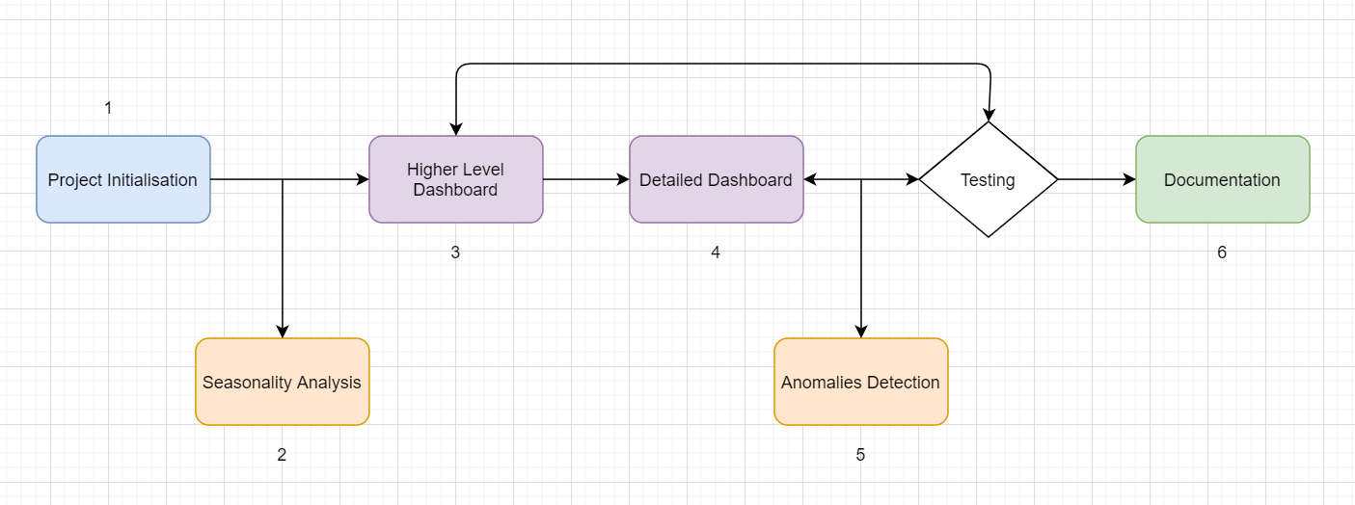

The project process follows:

1. Project initialisation:

* Understand the business problem and the project tasks;
* Communication with stakeholders to understand their requirements;
* Complete the Statement of Work

1. Since this project will use data from the Open Data Portal, in the meanwhile of waiting bus patronage data to be published, I will request internal data from the client to conduct seasonality analysis first;
2. Build the high-level dashboard:

* Contains Daily Journeys, Monthly Boarding Patronage and Service Reliability;
* There may be an optional part to show Customer Feedbacks, depending on whether the clients can get relevant data published;
* Once completed, pass the dashboard to the Business Service team for testing.

1. Build the detailed dashboard:

* Focus on the current month;
* Contains same components of the high-level dashboard with additions of Daily Average Patronage by hours, Boarding by Suburbs and Bus Hot Spots;
* In the meanwhile, modify the high-level dashboard according to the feedback from testing;
* Once completed, pass the detailed dashboard to the Business Service team for testing.

1. While waiting the dashboards to be tested, conducting the anomalies detection of bus patronage data.
2. After dashboards and analysis results are regarded as acceptable by the client; documentation will be collated:

* Power BI documentations to pass to the client;
* Data analysis report or case study.

## MILESTONE SCHEDULE

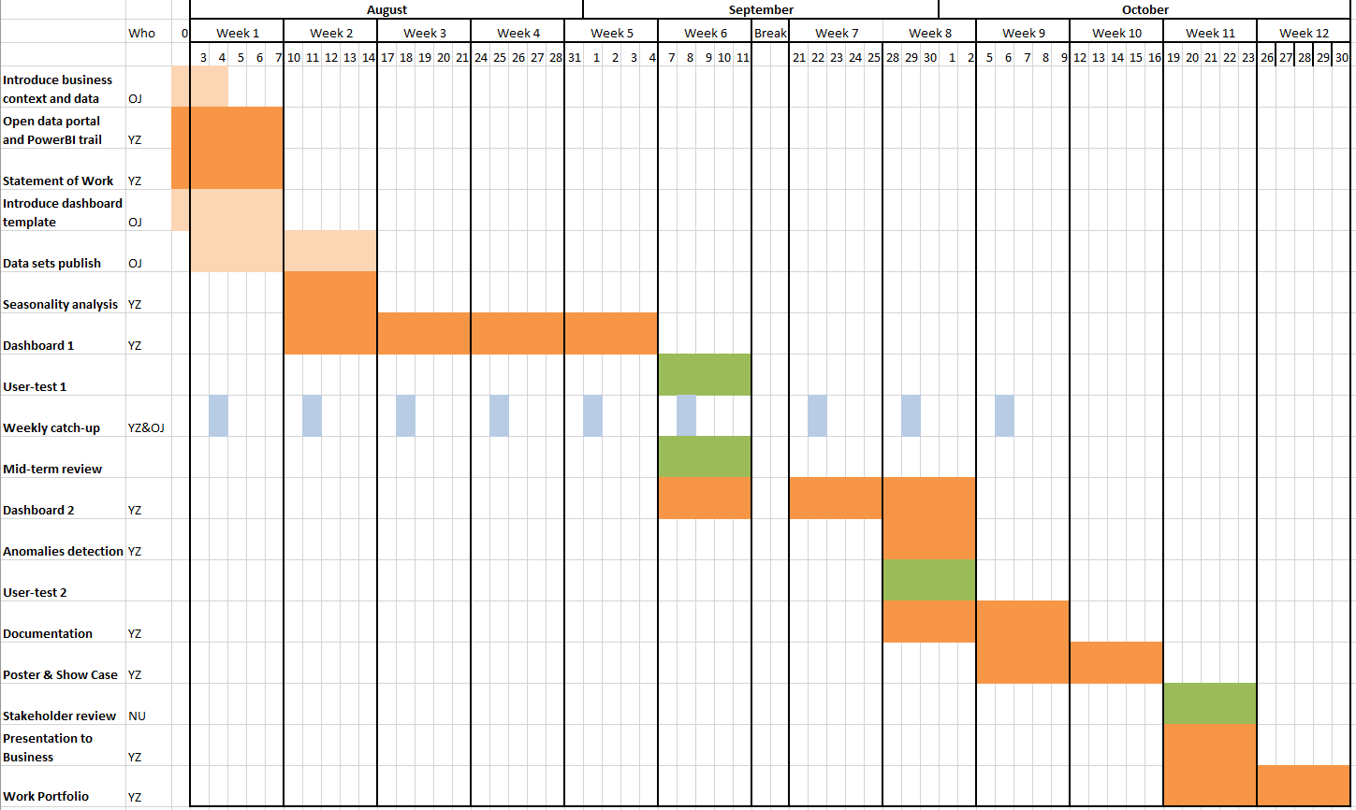

YZ- Yuchen Zhang (Analyst)

OJ- Olivia Jiang (Business Service Team, the Client)

NU- Nathan Urban (IDA Team, the Supervisor)

## DELIVERABLES

* Two dashboards
* Data analysis code and report
* Case study

## COST AND RESOURCES

1. **Potential cost:**

* Power BI Pro already licensed to Transport Canberra;
* Data sets involved in this project are free open source.

There’s no potential cost that need to be considered so far.

1. **Potential datasets:**

* Bus and Light Rail Patronage data
* Bus Stops
* Bus Routes
* Bus Service Reliability and Punctuality
* Customer Feedback
* Australian Public Holiday Date Data
* Canberra Suburbs Postcode Location Data

## RISK AND CONSRTAINTS

1. **Constraints:**

* For data security, the dashboards should only use data sets that are published on the Open Data Portal;
* The dashboards should be built according to the given template (allowing minor layout changes);
* The project should follow the milestone and be completed within 12 weeks.

1. **Risks:**

* Lacking of published data may cause incompletion of the dashboards. If this happens, we could temporarily remove relevant components from the dashboard template, and leave space for future extensions.

## SUCCESS

* Implementation of functionally efficient dashboards
* Completion of data analysis report and case study
* Collation of clear and extendable documentation

## CLOSURE

* Dashboards will be handed over to the clients for testing
* Data analysis report will be reviewed by the project owner
* Interns will present a final showcase at ANU

After each part is completed and approved, the interns will collate and hand over the Work Portfolio Package to the Project owner.

## ADDITIONAL INFORMATION

1. **Tooling:**

* **Power BI Pro** for dashboard building
* **BitBucket** for code sharing and version control
* **Teams** for meeting and communication

1. **Communication:**

* Workshops, Circles and Touchpoints with mentors at ANU
* Weekly catch-up meeting with clients
* Stand-up meetings on each Tue, Wed and Thu with the IDA team
* Fortnight meeting with business stakeholders

## REFERNECE

Cmd.act.gov.au. 2015. Proactive Release Of Data (Open Data) Policy. [online] Available at: <http://www.cmd.act.gov.au/__data/assets/pdf_file/0011/859430/2016-Proactive-Release-of-Data-Open-Data-Policy.pdf>.

Cityservices.act.gov.au. 2019. Open Data Strategy 2019-2021. [online] Available at: <https://www.cityservices.act.gov.au/__data/assets/pdf_file/0004/1466203/Open-Data-Strategy-2019-2021.pdf>.

## APPROVAL

|  |  |  |  |
| --- | --- | --- | --- |
| Student Name | Yuchen Zhang | Email | U5899265@anu.edu.au |
| Title | Master of Computing Candidate The Australian National University | | |
| Signature |  | Date |  |

|  |  |  |  |
| --- | --- | --- | --- |
| Sponsor Name | Olivia Jiang | Email | Olivia.Jiang@act.gov.au |
| Title | Business Analyst  Transport Canberra and Business Services  Transport Canberra and City Services | | |
| Signature |  | Date |  |

|  |  |  |  |
| --- | --- | --- | --- |
| Supervisor Name | Nathan Urban | Email | Nathan.Urban@act.gov.au |
| Title | Delivery Manager  Innovation, data & Analytics  Transport Canberra and City Services | | |
| Signature |  | Date |  |